LAB ACTIVITY (Lab-07)

1. Bank Account System
- Create an abstract class Account with common fields: accountNumber, balance.
- Add an abstract method withdraw().
- Implement constructors in the subclasses.
- Create subclasses: SavingsAccount, CurrentAccount that implement withdraw() differently.
- Create an interface Depositable with method deposit() → implement it in both subclasses.
- Show method overloading in deposit() (deposit(int amount), deposit(double amount)).

interface Depositable
{
void deposit(int amount);
void deposit(double amount);
}
abstract class Account
{
int accountNumber;
double balance;
Account(int accountNumber, double balance)
{
this.accountNumber= accountNumber;
this.balance= balance;
}
abstract void withdraw(double amount);
void showBalance()
{
System.out.println("Account No.:"+accountNumber+",Balance:"+balance);
}
}
class SavingsAccount extends Account implements Depositable
{
private static final double MIN_BALANCE=500.0;
SavingsAccount(int accountNumber, double balance)
{
super(accountNumber, balance);
}
void withdraw(double amount)
{
if(balance-amount>=MIN_BALANCE)
{
balance-=amount;
System.out.println("SavingsAccount:withdrawn"+ amount);
}
else
{
System.out.println("SavingsAccount:withdrawl denied! Minimum balance must be mantained");
}
}
public void deposit(int amount)
{
balance+=amount;
System.out.println("SavingsAccount: DEposited"+ amount);
}
public void deposit(double amount)
{
balance+=amount;
System.out.println("SavingsAccount: DEposited"+ amount);
}
}

class CurrentAccount extends Account implements Depositable
{
private static final double OVERDRAFT_LIMIT=1000.0;
CurrentAccount(int accountNumber, double balance)
{
super(accountNumber, balance);
}
void withdraw(double amount)
{
if(balance-amount>=OVERDRAFT_LIMIT)
{
balance-=amount;
System.out.println("CurrentAccount:withdrawn"+ amount);
}
else
{
System.out.println("CurrentAccount:withdrawl denied! Minimum balance must be mantained");
}
}
public void deposit(int amount)
{
balance+=amount;
System.out.println("CurrentAccount: DEposited"+ amount);
}
public void deposit(double amount)
{
balance+=amount;
System.out.println("CurrentAccount: DEposited"+ amount);
}
}
class bank
{
public static void main(String[] ar)
{
SavingsAccount sa=new SavingsAccount(1234, 3000.0);
CurrentAccount ca =new CurrentAccount(5678, 2000.0);
sa.showBalance();
sa.deposit(600);
sa.withdraw(3200);
sa.showBalance();
System.out.println("------------------------");
ca.showBalance();
ca.deposit(600);
ca.withdraw(1200);
ca.showBalance();
}
}

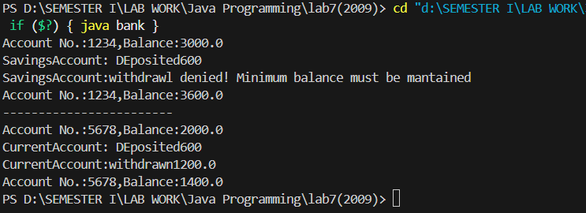

2. Vehicle Hierarchy
- Create an abstract class Vehicle with fields speed and fuel, and an abstract method mileage().
- Subclasses: Car, Bike, Truck → override mileage().
- Create an interface Acceleratable with accelerate() method.
- Show method overloading in accelerate() (accelerate(int increment), accelerate(int increment, int gear)).
- Subclasses implement both abstract methods and interface methods.

interface Acceleratable {
void accelerate(int increment);
void accelerate(int increment, int gear);
}

abstract class Vehicle {
double speed;
double fuel;

Vehicle(double speed, double fuel) {
this.speed = speed;
this.fuel = fuel;
}

abstract void mileage();

public void display() {
System.out.println("Speed: " + speed + " km/h, Fuel: " + fuel + " liters");
}
}

class Car extends Vehicle implements Acceleratable {
public Car(double speed, double fuel) {
super(speed, fuel);
}

@Override
public void mileage() {
double mileage = fuel * 15;
System.out.println("Car mileage: " + mileage + " km");
}

public void accelerate(int increment) {
speed += increment;
System.out.println("New Speed: " + speed);
}

public void accelerate(int increment, int gear) {
speed += increment+gear * 10;
System.out.println("New Speed(gear): " + speed);
}
}

class Bike extends Vehicle implements Acceleratable {
public Bike(double speed, double fuel) {
super(speed, fuel);
}

@Override
public void mileage() {
double mileage = fuel * 40;
System.out.println("Bike mileage: " + mileage + " km");
}

public void accelerate(int increment) {
speed += increment;
System.out.println("New Speed: " + speed);
}

public void accelerate(int increment, int gear) {
speed += increment+ gear * 10;
System.out.println("New Speed(gear): " + speed);
}
}

class Truck extends Vehicle implements Acceleratable {
public Truck(double speed, double fuel) {
super(speed, fuel);
}

@Override
public void mileage() {
double mileage = fuel * 8;
System.out.println("Truck mileage: " + mileage + " km");
}

public void accelerate(int increment) {
speed += increment;
System.out.println("New Speed: " + speed);
}

public void accelerate(int increment, int gear) {
speed += increment+ gear * 10;
System.out.println("New Speed(gear): " + speed);
}
}

public class MainVehicle {
public static void main(String[] args) {
// Car
System.out.println("---------Car -------------");
Car car = new Car(60, 20);
car.display();
car.accelerate(2);
car.accelerate(2, 2);
car.mileage();

System.out.println("--------Bike-------------");

// Bike
Bike bike = new Bike(40, 5);
bike.display();
bike.accelerate(3, 4);
bike.accelerate(3);
bike.mileage();

System.out.println("--------Truck--------------");

// Truck
Truck truck = new Truck(50, 50);
truck.display();
truck.accelerate(4);
truck.accelerate(4, 2);
truck.mileage();
}
}

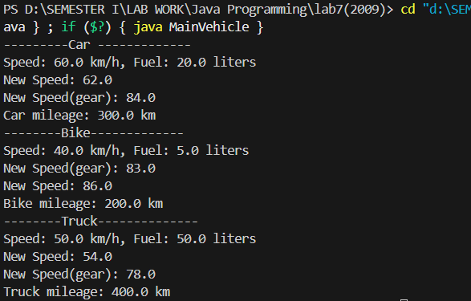

3. Shape Area Calculator
- Create an abstract class Shape with abstract method calculateArea().
- Subclasses: Circle, Rectangle, Triangle override calculateArea().
- In Rectangle, implement method overloading for area calculation (square vs rectangle).
- Create an interface Drawable with draw() method. Each shape implements it.

interface Drawable {
void draw();
}

abstract class Shape implements Drawable {
abstract double calculateArea();
}

class Circle extends Shape {
double radius;

Circle(double radius) {
this.radius = radius;
}

@Override
double calculateArea() {
return Math.PI * radius * radius;
}

@Override
public void draw() {
System.out.println("Drawing a Circle with radius " + radius);
}
}

class Rectangle extends Shape {
double length;
double width;

// Rectangle constructor
Rectangle(double length, double width) {
this.length = length;
this.width = width;
}

// Square constructor (overloading)
Rectangle(double side) {
this.length = side;
this.width = side;
}

@Override
double calculateArea() {
return length * width;
}

@Override
public void draw() {
if (length == width) {
System.out.println("Drawing a Square with side " + length);
} else {
System.out.println("Drawing a Rectangle " + length + " x " + width);
}
}
}

class Triangle extends Shape {
double base;
double height;

Triangle(double base, double height) {
this.base = base;
this.height = height;
}

@Override
double calculateArea() {
return 0.5 * base * height;
}

@Override
public void draw() {
System.out.println("Drawing a Triangle with base " + base + " and height " + height);
}
}

public class MainShape {
public static void main(String[] args) {
// Circle
Circle circle = new Circle(5);
circle.draw();
System.out.println("Circle area: " + circle.calculateArea());
System.out.println("---------------------------");

// Rectangle
Rectangle rectangle = new Rectangle(10, 5);
rectangle.draw();
System.out.println("Rectangle area: " + rectangle.calculateArea());

// Square using overloaded constructor
Rectangle square = new Rectangle(6);
square.draw();
System.out.println("Square area: " + square.calculateArea());
System.out.println("---------------------------");

// Triangle
Triangle triangle = new Triangle(8, 4);
triangle.draw();
System.out.println("Triangle area: " + triangle.calculateArea());
}
}

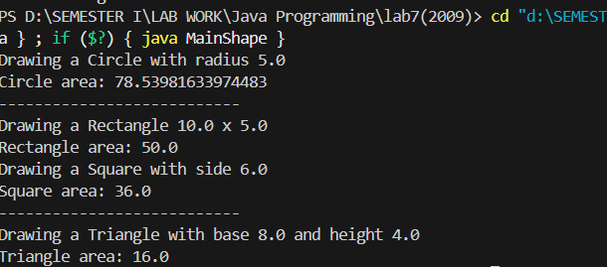

4. Employee Payroll System
- Create an abstract class Employee with abstract method calculateBonus().
- Subclasses: Manager, Developer, Intern implement it differently.
- Add constructors in each subclass.
- Create an interface Payable with calculateSalary() method.
- Show method overloading for calculateBonus() (bonus by % OR by fixed amount).

interface Payable {
double calculateSalary();
}

abstract class Employee {
String name;
double basicSalary;
String post;

Employee(String name, double basicSalary, String post) {
this.name = name;
this.basicSalary = basicSalary;
this.post = post;
}

abstract double calculateBonus(double percent);
abstract double calculateBonus(int fixedAmount);
}

class Manager extends Employee implements Payable {
Manager(String name, double basicSalary) {
super(name, basicSalary, "Manager");
}

@Override
double calculateBonus(double percent) {
double bonus = basicSalary * (percent / 100);
System.out.println(post + " " + name + " Bonus (" + percent + "%): " + bonus);
return bonus;
}

@Override
double calculateBonus(int fixedAmount) {
System.out.println(post + " " + name + " Bonus (fixed): " + fixedAmount);
return fixedAmount;
}

@Override
public double calculateSalary() {
return basicSalary;
}
}

class Developer extends Employee implements Payable {
Developer(String name, double basicSalary) {
super(name, basicSalary, "Developer");
}

@Override
double calculateBonus(double percent) {
double bonus = basicSalary * (percent / 100);
System.out.println(post + " " + name + " Bonus (" + percent + "%): " + bonus);
return bonus;
}

@Override
double calculateBonus(int fixedAmount) {
System.out.println(post + " " + name + " Bonus (fixed): " + fixedAmount);
return fixedAmount;
}

@Override
public double calculateSalary() {
return basicSalary;
}
}

class Intern extends Employee implements Payable {
Intern(String name, double basicSalary) {
super(name, basicSalary, "Intern");
}

@Override
double calculateBonus(double percent) {
double bonus = basicSalary * (percent / 100);
System.out.println(post + " " + name + " Bonus (" + percent + "%): " + bonus);
return bonus;
}

@Override
double calculateBonus(int fixedAmount) {
System.out.println(post + " " + name + " Bonus (fixed): " + fixedAmount);
return fixedAmount;
}

@Override
public double calculateSalary() {
return basicSalary;
}
}

public class PayrollSystem {
public static void main(String[] args) {
Manager m = new Manager("Alice", 80000);
Developer d = new Developer("Bob", 50000);
Intern i = new Intern("Charlie", 20000);

System.out.println(m.post + " " + m.name + " Base Salary: " + m.calculateSalary());
m.calculateBonus(20.0);
m.calculateBonus(10000);

System.out.println("--------------------------");

System.out.println(d.post + " " + d.name + " Base Salary: " + d.calculateSalary());
d.calculateBonus(10.0);
d.calculateBonus(5000);

System.out.println("--------------------------");

System.out.println(i.post + " " + i.name + " Base Salary: " + i.calculateSalary());
i.calculateBonus(5.0);
i.calculateBonus(2000);
}
}

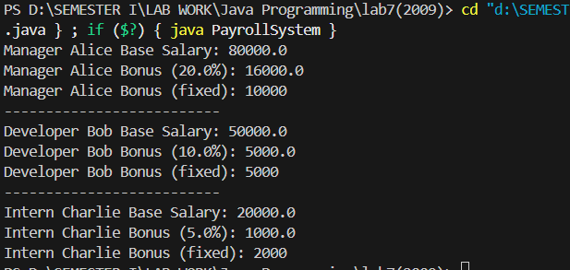

5. Library Management System
- Create an abstract class Book with abstract method getFinalPrice().
- Subclasses: EBook, PrintedBook implement it differently.
- Create an interface Discountable with method applyDiscount().
- Implement method overloading for applyDiscount() (percentage OR fixed).
- Constructors should be used to initialize title, author, price.

interface Discountable {
void applyDiscount(double percent);
void applyDiscount(int amount);
}

abstract class Book {
String title;
String author;
double price;

Book(String title, String author, double price) {
this.title = title;
this.author = author;
this.price = price;
}

abstract double getFinalPrice();
}

class EBook extends Book implements Discountable {
double downloadFee = 50;

EBook(String title, String author, double price) {
super(title, author, price);
}

@Override
public void applyDiscount(double percent) {
price -= price * (percent / 100);
}

@Override
public void applyDiscount(int amount) {
price -= amount;
}

@Override
double getFinalPrice() {
return price + downloadFee;
}
}

class PrintedBook extends Book implements Discountable {
double shippingCost = 100;

PrintedBook(String title, String author, double price) {
super(title, author, price);
}

@Override
public void applyDiscount(double percent) {
price -= price * (percent / 100);
}

@Override
public void applyDiscount(int amount) {
price -= amount;
}

@Override
double getFinalPrice() {
return price + shippingCost;
}
}

public class LibrarySystem {
public static void main(String[] args) {
EBook ebook = new EBook("Digital Java", "Alice", 500);
PrintedBook printed = new PrintedBook("Java Basics", "Bob", 800);

System.out.println("EBook: " + ebook.title + " by " + ebook.author);
ebook.applyDiscount(10.0);
System.out.println("Final Price after discount: " + ebook.getFinalPrice());

System.out.println("--------------------------");

System.out.println("PrintedBook: " + printed.title + " by " + printed.author);
printed.applyDiscount(200);
System.out.println("Final Price after discount: " + printed.getFinalPrice());
}
}

